What harvest means to me…
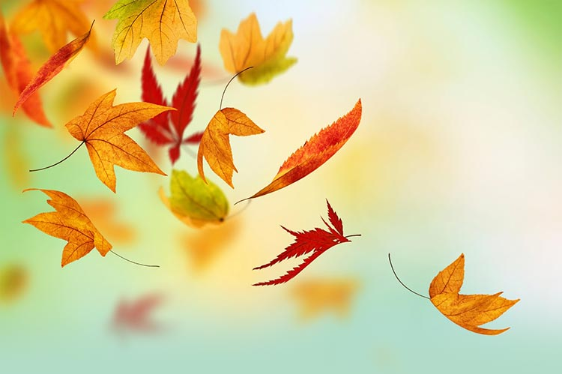
Harvest is the time when I am reminded about the need for generosity and love.

It’s the time for me to remember that God is incredibly generous and provides for me and my family and I love him for that.

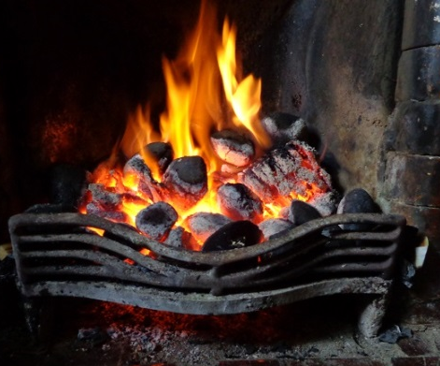
Harvest is the time for great fun, when conkers fall and leaves drift down forming rainbows on the ground of red, brown, orange and yellow.

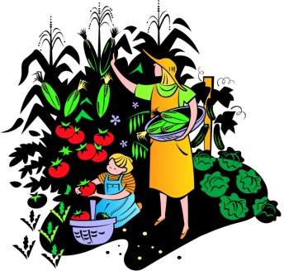
It’s a time to snuggle up and be all cosy by the fire.
Harvest is the time to think about the farmers in other countries who persevere to make a living, even though their working conditions are sometimes unfair. It reminds me to be respectful to one and all.

Harvest is the time to thank God for all the farmers and crops that they grow. We are lucky that we have all of the food that we need and we should be grateful because some people are not as fortunate as us.
We all have a great deal to be thankful for this harvest time.

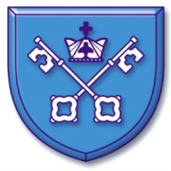
Written by the Year 6 children, at Mawdesley St Peter’s CE Primary School

